Channings Childcare December blog 2019

Channings have been getting very excited for Christmas. A busy time of year for us all.

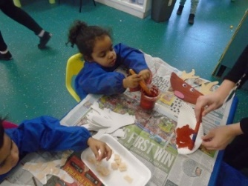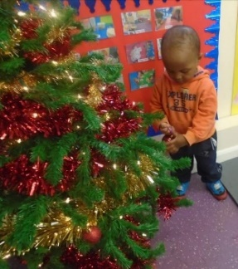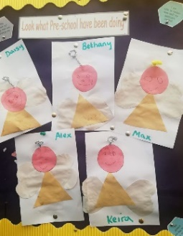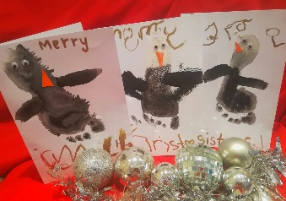

Early in December the children were busy sending letters to Santa Claus. They had great fun writing and collaging which toys they all like. I’m sure that the letters arrived at the North Pole in time.
We introduced our Channings Advent calendar, a photograph for the days leading up to the Christmas Day. We had beautiful collaged Christmas Angels, decorated trees, wonderful festive Tuff tray activities, the mischievous Christmas Elf was popping up everywhere, causing fun and so much more. We had Elf day and all of our staff and children dressed up. Everyone looked amazing and had great fun. Christmas jumper day gave everyone another excuse to dress up. The rooms have been buzzing with colour, creativity, painting, baking, games, smiles and lots of educational fun.
Our Christmas parties are throughout this week and Mother Christmas is visiting with her sack of goodies. There will be parties and treats for all children. It’s such a magical time.

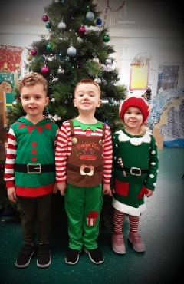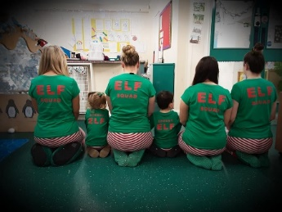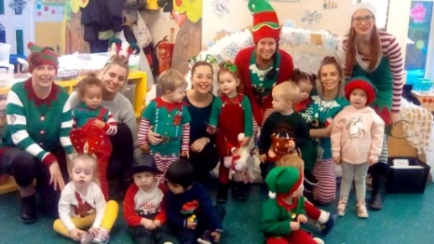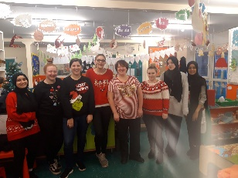

Meanwhile, our rooms are having a treat too. We are busy putting new equipment, new toys and games into all of our Channings. We will put some photographs on Facebook and onto our website.
We're in the festive spirit and have extended our offer for new children at Channings Middleton. If your child is under 30 months, then why not try us for 30 hours for only £30? Applicable until July 2020.
Please contact us for more details. Thank you
Tel: 0161 637 3363
Email. middleton.channingschildcare@gmail.com
https://www.channingschildcare.co.uk/our-nurseri…/middleton/

Our newest building, Channings Kingsway is having so much work done. The roof had to be replaced, however work seems to be going well and it’s looking good. We are hoping that everything will be ready for us to open in March 2020.

Channings Christmas closure details.
All Channings will close on Friday 20th December 2019.
We will re-open on Thursday 2nd January 2020.
Term time only children will return the week beginning Monday 6th January.

May we wish every single one of you a really wonderful Christmas. All of our hard working staff, managers, behind the scenes staff, all of our children, parents, grandparents, carers, friends, everybody. Thank you for your continued support.
Be kind to each other, relax and enjoy xx
See you all in 2020 xx

